- Using fertilizers in farming is an example of
- No cost production
- Low cost production
- High cost production
- None of these
- What is the process of growing two or more crops in a definite pattern?
- Crop rotation b) Inter-cropping c) Mixed cropping d) Organic cropping
- Which of the following is an energy yielding crop?
- Wheat b) Mustard c) Gram d) Groundnut
- Arrange these statements in correct sequence of preparation of green manure.
- Green plants are decomposed in soil
- Green plants are cultivated
- Plants are ploughed
- Decomposition
- i---ii---iv—iii b) ii—iii---i—iv c) ii---iii—iv—I d) iii—ii—iv—i
- The leguminous crop whose seeds are rich source of edible oil is
    - Groundnut. B) Sunflower C) Linseed. D) Lentil
- Crop variety improvement is done for the following reasons, except
    - Increased productivity of crop per unit area
    - Tallness and profused branching of cereal crops
    - Baking quality of wheat
    - Resistance to pests
- Bio fertilizers used in organic farming include
    - Symbiotic and free living nitrogen fixing bacteria
    - Nitrogen fixing cyanobacteria
    - Phosphate soluble microorganisms
    - All of these
- Which of the following is true for crop rotation?
    - Growing two or more crops simultaneously in same piece of land
    - Growing different crops in pre planned succession
    - Definite pattern is maintained
    - Seeds are mixed before sowing
- Which of the following is not an advantage of using fertilizers?
    - It causes water pollution due to surface run off
    - They are compact and nutrient specific
    - They can change pH
    - Both a and c
- Which of the following is not true about essential nutrients for plants?
    - Total 16 nutrients are required for plants
    - 13 nutrients of 16 are supplied from soil
    - Non-mineral nutrients like Carbon, Hydrogen and Chlorine are supplied through air and water
    - Nitrogen, Phosphorus and Potassium are considered as primary nutrients

- The figure shows two crop fields (plots A and B) have been treated by manures and chemical fertilizers respectively, keeping other environmental factors the same. Observe the graph and answer the following question.
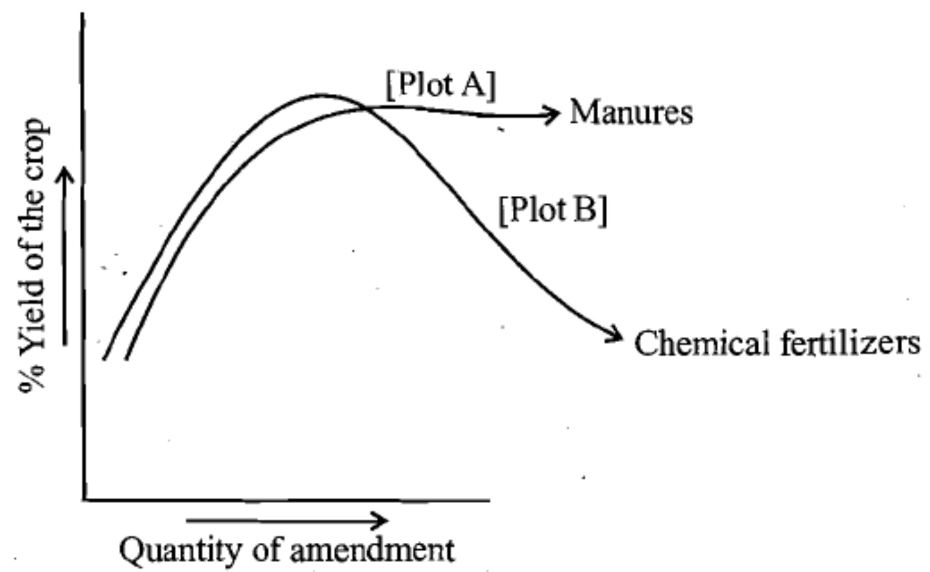

  - Why does plot B show a sudden increase and then a gradual decrease in yield?
  - Why the highest peak of the graph in plot A is slightly delayed?
  - What is the reason of different patterns of two graphs?
- Which of the following conditions will give the most benefits? Why?
    - Farmers use high-quality seeds do not adopt irrigation or use fertilizers.
    - Farmers use ordinary seeds adopt irrigation and use fertilizer.
    - Farmers use quality seeds adopt irrigation use fertilizer and use crop protection measures.
- Why legume crops do not require nitrogenous fertilizers?

